TrustCore Developer Guide
Last updated 22 October 2026. Written for whoever picks up the TrustCore code next, frontend or backend. If you want to know how to use the dashboard rather than change it, that's the User Guide.
The short version: an Angular 15 dashboard talks to a Laravel 11 API over JSON, and nearly every screen runs on one idea, a configurable "Collections" content model where the database columns, the API and the form inputs all agree on a naming convention. Read section 3 before you change anything. Most of the rest follows from it.

1. What's in the package
TrustCore/
├── Trustcore-Backend/ Laravel 11 API (no vendor/ folder, see 2.2)
├── Trustcore-Frontend/ Angular 15 dashboard (trust-core-updates branch)
└── TrustcoreDB.sql Production database export, 22 Oct 2026
Each code folder has its own README.md with step-by-step setup for a new machine, and Trustcore-Frontend/deploy/ holds the two .htaccess files the live host relies on.
Once everything is running, these are the default local addresses:
Service | Address
Laravel API | http://127.0.0.1:8000
Angular dev server | http://127.0.0.1:4200
MySQL | Whatever your local install uses (3306 by default)

2. Getting it running locally
You'll need PHP 8.2 or newer, Composer, MySQL 8, and Node 18. Not a newer Node, see 2.3.

2.1 Database
Create an empty database and load the export into it:
mysql -u root -p -e "CREATE DATABASE trustcore CHARACTER SET utf8mb4 COLLATE utf8mb4_unicode_ci;"
mysql -u root -p trustcore < TrustcoreDB.sql
The import should finish without errors and leave you with roughly 80 tables.

2.2 Backend
cd Trustcore-Backend
cp .env .env.production.bak # keep the live values for reference
composer install
php artisan storage:link
chmod -R 775 storage bootstrap/cache
Then edit .env for local use. These are the values that matter:
APP_ENV=local
APP_URL=http://localhost:8000
FRONTEND_URL=http://localhost:4200
DB_HOST=127.0.0.1
DB_PORT=3306
DB_DATABASE=trustcore
DB_USERNAME=root
DB_PASSWORD=your-local-password
Start it with php artisan serve --host=127.0.0.1 --port=8000.
Three quick checks tell you it's wired up properly. php artisan about should report the mysql driver and the local environment. GET /api/settings needs no login and should come back with the company name and logo from the database. And POST /api/login with a real account from the import should return 200, a user object and a Sanctum token.
Don't run php artisan migrate against the imported database. migrate:status lists three migrations as pending (settings, templates and templates_meta) even though those tables already exist in the export, so a migrate run would fail on them. Only migrate if you're starting from an empty database.

2.3 Frontend
cd Trustcore-Frontend
npm install --legacy-peer-deps
npx ng serve
Two things will trip you up if you skip them.
Use Node 18. The project's postinstall step runs ngcc, and ngcc breaks on Node 23. If your system Node is newer, install 18 alongside it (Homebrew's node@18, nvm, or similar) instead of replacing it. Nothing in the frontend tells you this, so adding an .nvmrc would save the next person some time.
--legacy-peer-deps isn't optional. package.json still pins @angular/google-maps@^12.2.13, left over from before the rest of the app moved to Angular 15. npm's strict resolver refuses that combination outright with ERESOLVE. The flag resolves it the way npm did before version 7, which is how the project has always been built. The proper fix is to upgrade or replace google-maps, which only backs one map component.
src/environments/environment.ts already points baseEndpoint at http://127.0.0.1:8000/api/, so a local frontend talks to a local backend with no changes. environment.prod.ts points at the production API on trustcore.ch, and that's what a production build uses.

2.4 The one frontend not to use
Production only has a compiled build of the frontend (the hashed .js files in the web root). Its API address was baked in at build time as https://trustcore.ch/trustcore/trustcore-backend/public/api/. Serve that build locally and it will quietly talk to the live production API, not yours. Treat it as a record of what's deployed and nothing more.

3. The Collections model (read this first)

3.1 The idea
A typical Laravel app would have an offers table, a model, a migration and a controller, and every new product line would mean all four again. TrustCore doesn't work that way. It has:
- a collections table with one row per content type (Offers, Health Insurance, each insurer's product line), 85 rows right now;
- templates and templates_meta, which define named sets of typed fields;
- and one physical table per collection, named [handle]_meta (offers_meta, health_insurer_meta, insurance_model_hsi_meta and so on), where every field in the template is a real typed column.
That last point matters. It isn't a key/value table. Each collection gets a proper schema, so querying it is as quick as querying any other table.
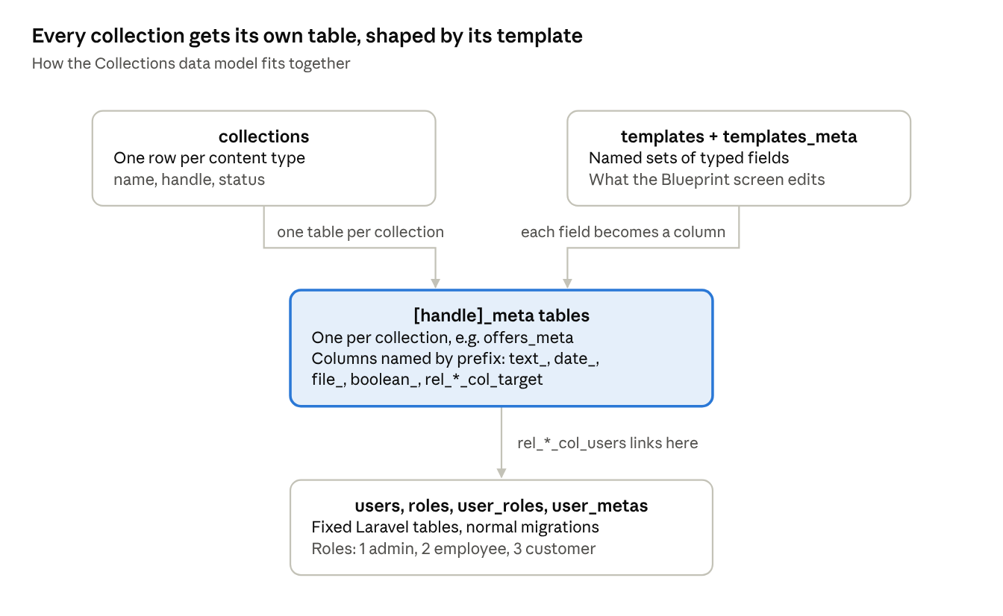
Collections data model · 4 table groups

3.2 The naming convention
Column names carry their own type. The backend reads the prefix to decide how to store and validate a field, and the frontend reads the same prefix to decide which input to draw. That shared convention is why someone can add a field from the Blueprint screen without touching code. It's also the thing most likely to break if anyone renames columns by hand.
Prefix | Meaning | Rendered as | Example from offers_meta
text_ | Plain text | Text input | text_meta_title_req, text_status
date_ | Date | Date picker | date_birthdate (in user_metas)
file_, image_, files_, images_, upload_, uploads_ | File or image | Upload widget | file_pdf
rel_[name]_col_[target] | Link to another collection or table | Dropdown filled from the target | rel_customer_req_col_users, rel_templates_req_col_collections
boolean_ | Yes or no | Toggle | Used across the product coverage tables
_req (anywhere in the name) | Required field | Validated on both sides | text_meta_title_req
On the frontend the prefix matching lives in components/entryedit/entry.component.ts (isTextField, isDateField, isFileField, isRelationField), and the field builder that creates these names is components/blueprint/blueprint.component.ts. On the backend it's CollectionController and CollectionMetaController.

3.3 What this means day to day
Need a new field on something that already exists? Add it through the Blueprint screen or the add-field endpoint, with the right prefix. Don't write a migration for it. Need a whole new product type? Create a collection and a template, not a model. Migrations are only for the fixed tables underneath: users, roles, settings and the like.

4. Logins and permissions

4.1 How login works
The frontend uses a custom Nebular auth strategy, src/app/auth/custom-password-auth-strategy.ts, registered in app.module.ts. On a successful POST /api/login it saves the whole user object (roles and profile included) to localStorage.user and the Sanctum token to both localStorage.AuthToken and localStorage.token. Then it sends the browser to /pages/dashboard with a full page load rather than a router navigation, which is why the menu and role checks always rebuild from localStorage. Forgotten passwords go through requestPassword() on the same class, which posts to /api/request-pass.
On the backend, Sanctum issues the token (stored in personal_access_tokens) through Auth\AuthenticatedSessionController@store. The User model has roles() through user_roles and meta() for the profile in user_metas. Roles are fixed: 1 admin, 2 employee, 3 customer.

4.2 Where permissions are actually checked
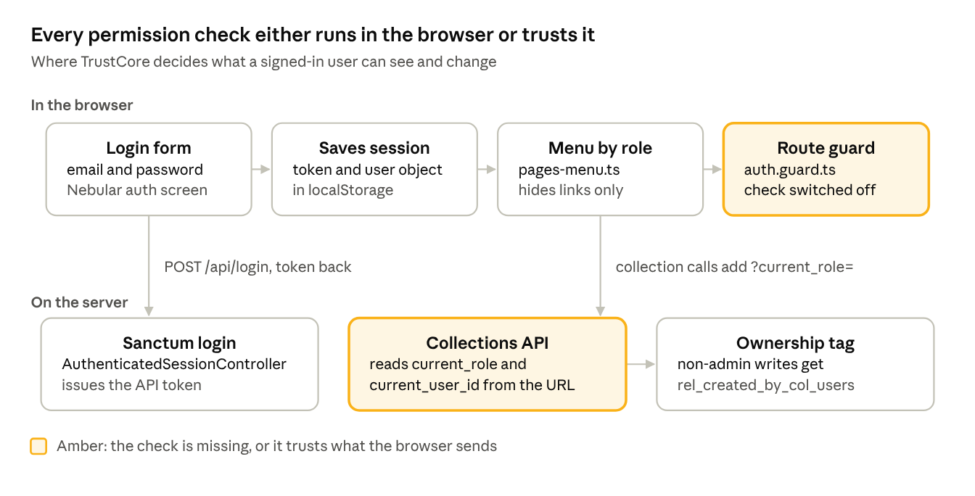
Permission checks · browser and server
Three places try to decide what a user can do, and none of them is a real security boundary yet.
The menu (pages/pages-menu.ts). Each role has a list of things it may view, and a menu item is only added if the role's list mentions it. This works, but it's cosmetic. It hides links; it doesn't block anything. The Reports item is commented out here even though it's still in the permission lists.
The route guard (auth.guard.ts). On the trust-core-updates branch the guard reads the user's role and the route's permission data, and the start of a real check is there. The part that would actually redirect someone is commented out, though, so right now the guard logs what it finds and lets everything through. On the older master branch the guard only checked that a token existed.
The backend ownership tag (CollectionMetaController). Every create and update call from the frontend adds current_user_id and current_role to the query string. If the role isn't admin, the backend sets rel_created_by_col_users to that user id, so non-admins own what they create. The catch is that both values come from the request, not from the authenticated token, so anyone who edits the URL can claim to be an admin. The fix is to read the user and role from $request->user() on the server and ignore those query parameters entirely.

4.3 A small bug in the permission lists
accessControl() writes each role's permissions as one comma-separated string inside an array, ['offers, reports, settings, dashboard'], instead of ['offers', 'reports', 'settings', 'dashboard']. The .includes('offers') calls still work, but only because they're doing a substring search on that single string. Add a permission whose name is part of another one and it will match the wrong thing. Worth fixing before the list grows.

5. Offer automation (Power Automate)
Creating an offer doesn't build the PDF inside TrustCore. Laravel saves the offer, hands the job to a Microsoft Power Automate flow, and waits for the flow to call back. It's the one part of the system that runs outside this codebase, so it's worth knowing exactly where the boundary sits.
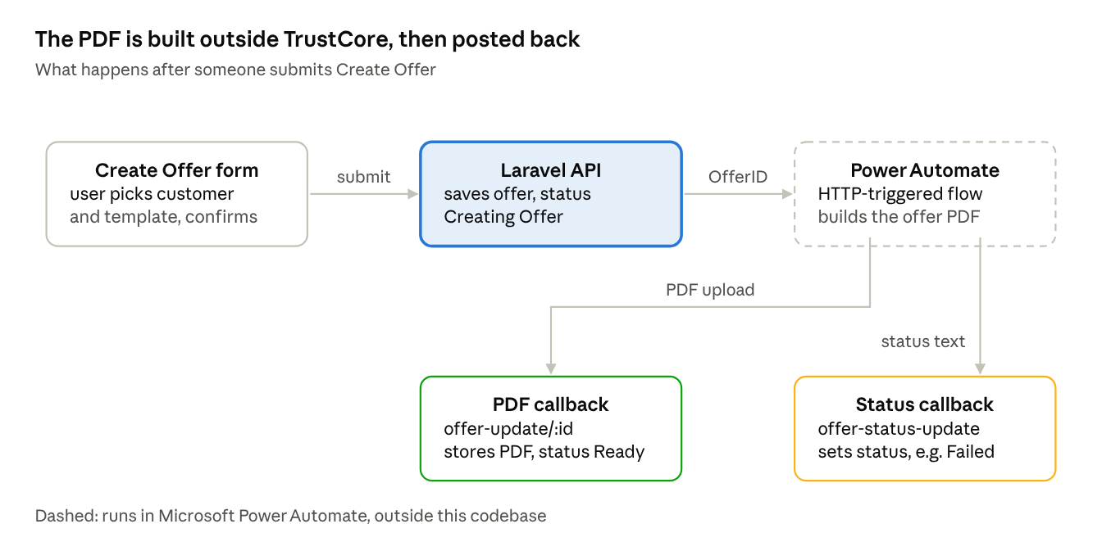
Offer automation · submit, flow, two callbacks

5.1 What happens when someone submits Create Offer
- The user fills in the Create Offer form (customer, template, and the template's own fields) and confirms the prompt. The form posts to POST /api/collections/offers/entry/create.
- CollectionMetaController@create_entry inserts the row into offers_meta with text_status forced to Creating Offer, then answers "Offer has been created. You'll receive an email with offer PDF".
- In the same request, createOffer() sends {"OfferID": <new id>} as JSON to the flow's HTTP trigger. Only the ID goes out, so the flow has to fetch the offer details itself. Laravel doesn't wait for the flow and ignores whatever the trigger answers.
- The flow does its work inside Power Automate. None of that logic is in this repository. The SMS endpoints (/api/incoming/sms and /api/latest-otp) exist alongside it and are most likely there so the flow can complete a one-time-code sign-in somewhere, but that needs confirming in the flow itself.
- The flow reports back through two endpoints:
  - POST /api/webhook/offer-status-update with {"ID": <offer id>, "status": "<text>"} writes that text straight into text_status. This is how offers end up as Failed.
  - POST /api/webhook/offer-update/{offerId} with a multipart pdf file saves it to public/assets/offers/ as offer_<name>_<timestamp>.pdf, stores the path in file_pdf, and sets the status to Ready.
- The customer receives the PDF by email. Nothing in the Laravel code sends that email, so it comes from the flow.

5.2 Offer statuses
Status | Set by | What it means
Creating Offer | Laravel, on submit | Handed to the flow, nothing back yet
Ready | Laravel, when the flow uploads the PDF | PDF stored and linked to the offer
Failed, or any other text | The flow, through offer-status-update | The flow hit a problem and said so
At export time there were 40 offers at Ready, 11 at Failed and 2 still at Creating Offer.

5.3 Before you touch it
- Don't create offers on a local copy. The trigger address is hard-coded to the production flow, so a local submit starts the real flow with a local offer ID. Whatever the flow then posts back goes to the address configured in the flow, which may be production, where that ID belongs to a different, real offer. Move the trigger address into .env first and leave it empty locally.
- The trigger address is a secret. It carries the flow's access signature, so anyone who has it can start the flow. It belongs in .env (something like OFFER_FLOW_URL) and out of the code. A commented-out line shows it used to come from each template's text_flow_url_req field. Today every template goes to the same flow.
- The flow only fires if the chosen template has data. createOffer() checks the template's [handle]_meta table for a row first. If it's empty, the offer stays at Creating Offer and nobody is told.
- Nothing times out or retries. If the flow never calls back, the offer sits at Creating Offer indefinitely. The two in the export are in that state.
- The callbacks and SMS endpoints aren't protected. They sit outside the Sanctum route group and don't check any shared secret. Add one (for example a header the flow sends and a small middleware checks) before anything else changes here.
- Check which host the flow calls back to. Both callbacks should go to https://trustcore.ch/trustcore/trustcore-backend/public/api/. Confirm that in the flow itself, since nothing in this codebase controls it.
- Status is free text. The flow decides the wording; Laravel stores it and the dashboard shows it as is. Adding a new status means changing the flow, not this code.

6. API reference
All routes live in Trustcore-Backend/routes/api.php under the /api/ prefix unless noted otherwise.
Area | Method and path | Handled by
Auth | POST /api/login | Auth\AuthenticatedSessionController@store
 | POST /api/logout | Auth\AuthenticatedSessionController@destroy
 | POST /api/request-pass | Auth\PasswordResetLinkController@store
 | POST /api/reset-password | Auth\NewPasswordController@store
 | POST /register, /login, /logout (web, session based) | Auth\RegisteredUserController@store and friends
 | GET /sanctum/csrf-cookie | Sanctum
 | POST /email/verification-notification, GET /verify-email/{id}/{hash} | Auth\EmailVerificationNotificationController, Auth\VerifyEmailController
Users | GET /api/user/all | UserController@index
 | GET /api/user/detail, GET /api/user/detail/{id} | UserController@show
 | POST /api/user/register | Auth\RegisteredUserController@store
 | POST /api/user/edit/{id} | Auth\RegisteredUserController@store
 | DELETE /api/user/delete/{id} | UserController@destroy
 | GET /api/user/reports/all | CollectionController@reports
Roles and settings | GET /api/roles | RolesController@index
 | GET and POST /api/settings, DELETE /api/settings/{key} | SettingsController
Collections | GET /api/collections/all, GET /api/collections/all/templates | CollectionController@all_collection
 | POST /api/collections/create | CollectionController@store
 | GET /api/collections/show/{handle} | CollectionController@show
 | PUT /api/collections/edit/{handle} | CollectionController@update
 | DELETE /api/collections/delete/{handle} | CollectionController@destroy
 | POST /api/collections/{handle}/add-field, PUT .../fields/edit, DELETE .../fields/delete, GET .../get-fields | CollectionController, CollectionMetaController
Entries | POST /api/collections/{handle}/entry/create | CollectionMetaController@store
 | GET /api/collections/{handle}/entry-detail/{id} | CollectionMetaController@show
 | PUT /api/collections/{handle}/entry-update/{id} | CollectionMetaController@update
 | DELETE /api/collections/{handle}/entry-delete/{id} | CollectionMetaController@destroy
Offer webhooks | POST /api/webhook/offer-status-update | CollectionMetaController@update_offer_status
 | POST /api/webhook/offer-update/{offerId} | CollectionMetaController
SMS codes | POST /api/incoming/sms | SmsController@receiveSms, which pulls a 6-digit code out of the message and writes it to public/otp/otp.json
 | GET /api/latest-otp | SmsController@getLatestOtp
Misc | GET /api/clear-cache | Inline closure
 | GET /up | Laravel health check
Every collection and entry call from the frontend appends ?current_user_id=...&current_role=.... Section 4.2 explains why that needs to change.
CORS is open to every origin (allowed_origins: ['*']) with credentials turned off. That's fine for token auth from a separate frontend, but tighten it if cookie-based Sanctum auth ever comes into play.

7. Frontend structure

7.1 Routes
All of these sit under /pages/ in src/app/pages/pages-routing.module.ts and pass through AuthGuard.
Path | Component | Notes
dashboard | ECommerceComponent | Landing page after login
collections/templates/all | CollectionListingComponent | All templates
collections/all | CollectionListingComponent | All collections
settings/site | SitesettingsComponent | Site-wide settings (admin)
settings/user | UsersettingsComponent | Personal settings
:handle | CollectionTableComponent | Generic: renders any collection's entries by handle. This is how Offers, Customers and the rest are drawn; there's no dedicated OffersComponent
:handle/blueprint | BlueprintComponent | Field builder for the collection's template
:handle/entry/:entryId, :handle/create, :handle/edit/:id | EditEntryComponent | Generic create and edit form, driven entirely by the prefixes in 3.2
customers, reports | CollectionTableComponent | Explicit routes for two handles that the generic route would also catch
users/list, users/list/all | UsersComponent | Staff and customer user grid
user/profile, user/profile/create, user/profile/:id | UsersComponent | Same component, reused for profiles
roles/all | RolesComponent | Role management
The /auth/... routes are Nebular's stock login, register, logout, request-password and reset-password components, wired to the custom strategy from 4.1.

7.2 Where things live
Trustcore-Frontend/src/app/
├── auth/custom-password-auth-strategy.ts login and forgot-password calls
├── auth.guard.ts route guard (see 4.2)
├── components/
│ ├── collections/
│ │ ├── collection-listing/ list of collections and templates
│ │ └── collection-table/ generic entry table for any :handle
│ ├── entryedit/ generic create/edit form, prefix parsing
│ ├── blueprint/ template field builder
│ ├── users/ user grid with PDF and Excel export
│ ├── roles/, sitesettings/, usersettings/
│ └── link-render/ renders relation links in tables
├── pages/
│ ├── pages-menu.ts sidebar menu and role visibility
│ ├── pages-routing.module.ts route table (7.1)
│ ├── users/create-user/, users/edit-user/
│ └── dashboard/, e-commerce/, charts/, ... stock ngx-admin pages, mostly unused
├── services/
│ ├── collections.service.ts every Collections API call
│ ├── users.service.ts user CRUD and reports
│ └── blueprint.service.ts, site-settings.service.ts
├── shared/, pipes/, translations/
└── ../environments/environment.ts baseEndpoint for local and prod

8. Which frontend branch to use
Two copies of the Angular source were supplied, master and trust-core-updates. Both install from the same package.json and both compile cleanly. Trustcore-Frontend/ holds trust-core-updates, and it's clearly the newer of the two. Compared with master it adds:
- the pages/users/ module, with dedicated create-user and edit-user screens;
- pipes/, shared/ (a new SharedModule, registered in app.module.ts) and translations/, which pages-menu.ts uses to translate menu labels;
- components/link-render/, plus a custom-link-render.component.ts inside collection-listing/;
- components/entryedit/entry.module.ts and a pages/dashboard/charts-panel addition;
- a rewritten auth.guard.ts with the half-built role check described in 4.2;
- a baseurl entry in environment.ts.
Before releasing it, either finish the route guard check or take it out, and fix the permission list bug from 4.3. Shipping either one half done is worse than shipping neither.

9. Known issues
- The route guard doesn't block anything yet (4.2). Menus hide links, but typing a URL still gets you in.
- The backend takes the user's role from the query string, not the token (4.2).
- Permission lists are one string per role instead of an array (4.3).
- The old master branch's environment.prod.ts points at a server that's no longer in use. Trustcore-Frontend/ correctly points at trustcore.ch, so this only matters if someone builds from master.
- @angular/google-maps is several major versions behind the rest of Angular (2.3).
- Node 18 is required and nothing in the repository says so (2.3).
- Three migrations show as pending even though their tables exist (2.2).
- Production holds only a compiled frontend. The source in Trustcore-Frontend/ should go into version control alongside the backend.
- The source as originally supplied carried leftovers: src-old/, src-bk/ (with __MACOSX junk inside) and a package copy.json with outdated dependencies. They're not in Trustcore-Frontend/, but they should be deleted from the original repository too.
- A separately supplied copy of the backend (trust_core.zip) has a GitHub personal access token in its .git/config remote URL. Revoke that token.
- APP_DEBUG=true in the production .env.
- CORS is open to every origin (section 6).
- Test data in production: about 15 template_test_* collections and a test@test.com account.
- A 306 MB site.zip from July 2025 sits in the production web root and may be publicly downloadable. Check what's in it, then remove it.
From the offer automation review (section 5):
- The Power Automate trigger address, signature included, is hard-coded in CollectionMetaController::createOffer().
- The two offer callbacks and the two SMS endpoints have no authentication or shared secret.
- Offers can stay at Creating Offer forever: no timeout, no retry, and a silent skip when the template has no data.
- Creating an offer on a non-production copy starts the production flow.

10. Database reference

10.1 Fixed tables
users, roles, user_roles, user_metas, password_reset_tokens, sessions, personal_access_tokens, cache, cache_locks, jobs, job_batches, failed_jobs, migrations, settings.

10.2 The dynamic layer
collections (85 rows), templates and templates_meta (35 templates), and one [handle]_meta table per collection, following the naming convention in section 3. Here's offers_meta as an example:
Column | What it holds
text_meta_title_req | Offer title
rel_customer_req_col_users | The customer the offer belongs to
collection_id | Which collection or product the offer is for
file_pdf | Path to the generated PDF, under public/assets/offers/
text_status | Offer status
rel_templates_req_col_collections | The template and collection that produced it

10.3 Counts at export time
23 users, 52 offers, 35 templates, and 112 offer PDFs on disk (older versions included).

